1. Install Python version 3.10.10 according to your computer. Install window installer for windows and mac installer for mac. Currently, it is the most stable version of python so you won’t have any problem installing the necessary libraries. Python 3.10.10 (<https://www.python.org/downloads/release/python-31010/>)
2. Open main.py file in vs code. Then open the terminal in vs code.

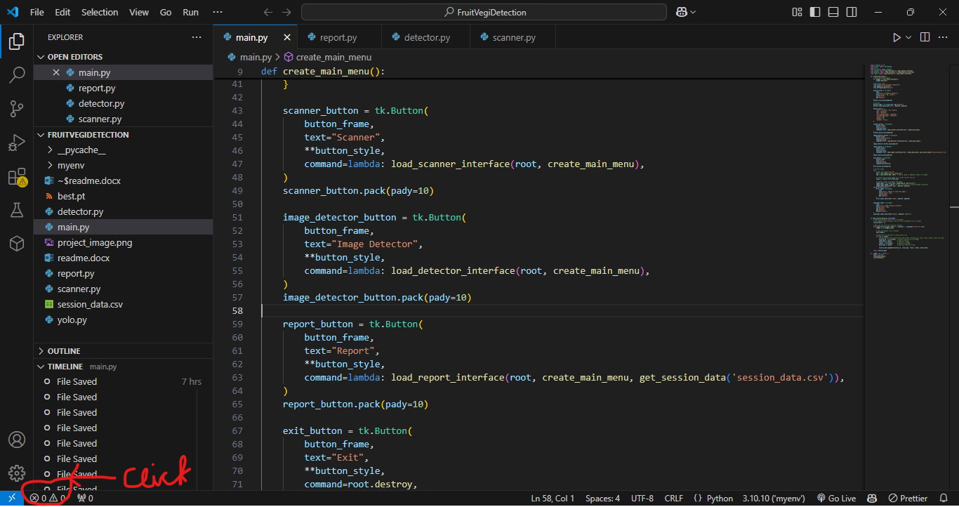

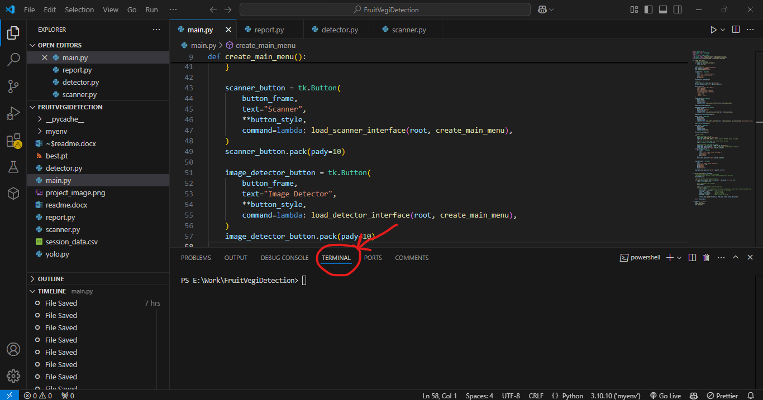

Also make sure that your vs code is using 3.10.10 compiler  
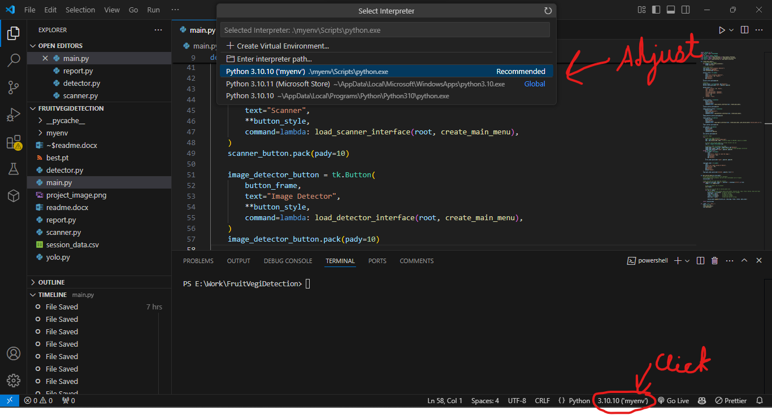

1. Now create an environment by typing “python –m venv myenv”

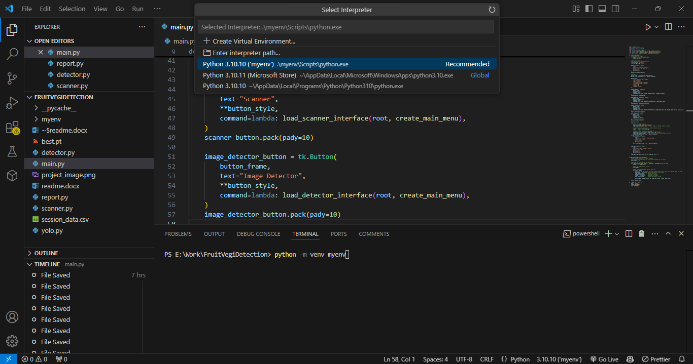

1. Now change your compiler to myenv you will see that at the end of your python version there is (‘myenv’). Switch to that.
2. Now activate that environment by locating that folder in your file manager.

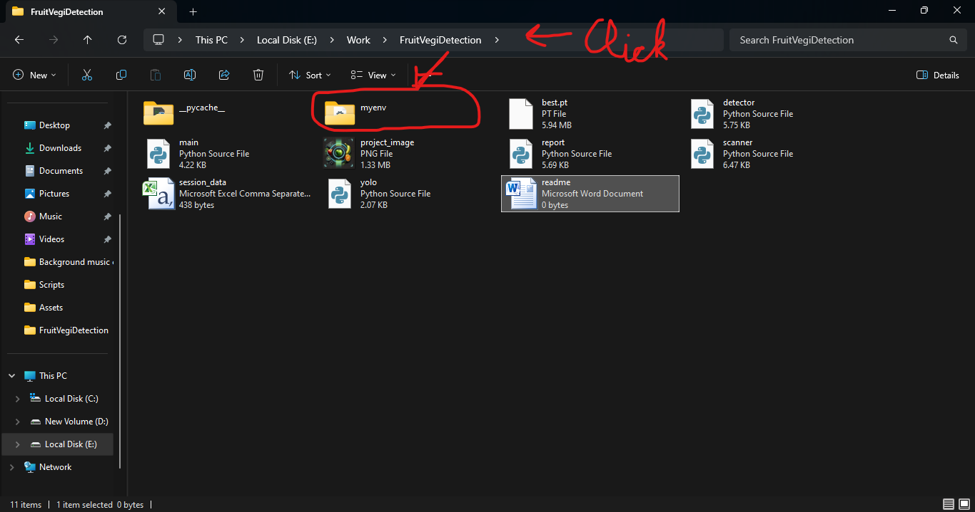  
click on the location panel and type cmd and press enter. That will open cmd with location of that folder. In this way you will easily target the environment without having a need to locate it manually.

1. Now type myenv\Scripts\activate to activate env. It will look like this  
   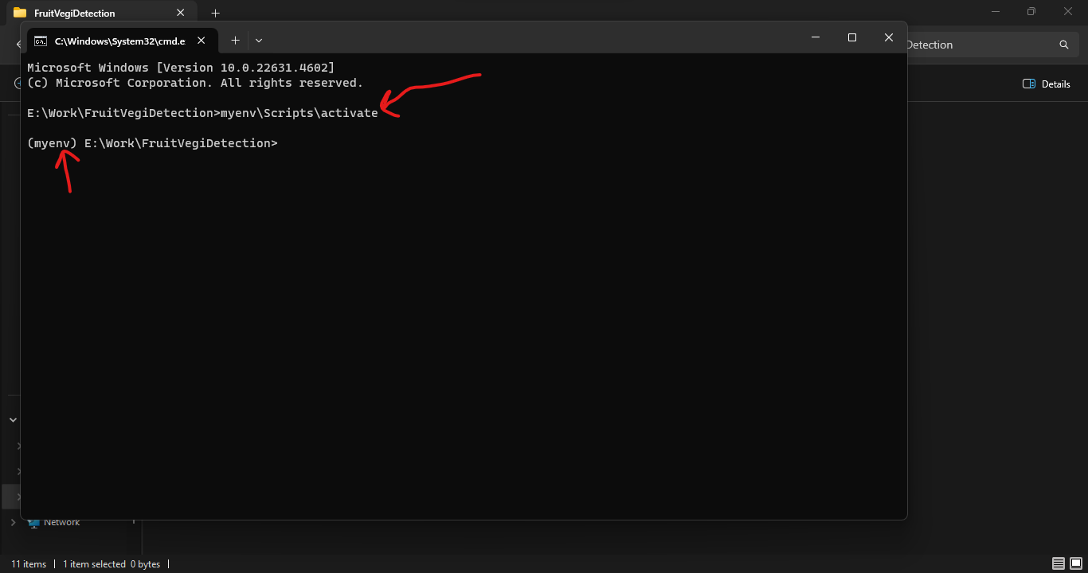
2. Now in that environment you download the libraries so that once your project is over you can remove the unnecessary libraries if you don’t need them. Now install necessary libraries using pip.

pip install pillow ultralytics opencv-python matplotlib  
  
And now you will be able to run the code with ease. If libraries are not being install or are giving error then check python version of myenv and if it is not 3.10.10 then firstly check version of python of windows. Make sure it is 3.10.10 and then recreate myenv by first deleting the previous one and then creating a new one in the same way as above and then check for any errors.